Microsoft Notepad User Guide

Author—Vinay Kulkarni (Mobile: 9591098884)

Date—July and August 2024

Contents

About Snipping Tool 4

Target audience 4

Key Features of Snipping Tool 4

Uses of Snipping Tool 4

Font style used in this guide 5

Customer support 5

Social media links 5

Chapter-1: Snipping Tool features 6

Start Snipping Tool in Microsoft Windows 11 and Microsoft Windows 10 6

Start Snipping Tool in Microsoft Windows 8 6

Components of Snipping Tool 6

Title bar 6

Menu bar 6

Status bar 7

Text area 7

Tabs 7

File tab 7

Edit tab 7

View tab 7

Format tab 7

Image showing title bars and various tabs 8

Chapter-2: Manage Files 8

Create a new file in a new tab 8

Create a new file in a new window 9

Open an existing File 9

Save a file 9

An image showing the Save and Save As features of Notepad 10

Set Header in Notepad 10

Set Footer in Notepad 11

Change the Header and Footer commands in Notepad 11

Close a file 11

Chapter-3: Manage Default Settings 12

Set the page orientation 12

• Portrait 12

• Landscape 12

• Margins 12

Wrap text 12

Enable autocorrect 13

Enable spell check 13

Set the page appearance 13

• Light 13

• Dark 13

• Use system settings 13

Set the font properties 14

• Family 14

• Style 14

• Size 14

Chapter-4: Print a document in Notepad 14

Chapter-5: Frequently Asked Questions on Notepad – FAQs 14

Further topics of Microsoft Notepad are as follows: 15

# About Snipping Tool

A Microsoft Notepad application is a simple text editor that comes pre-installed with the Microsoft Windows operating system and is designed to create, edit, and manage plain text, and store text files in .txt format. If a file is not in plain text format or contains a special format, it is not supported in Notepad.

It also provides advanced features such as spellchecker, auto-save, find & replace, header & footer. You can also see the cut, copy, paste, undo & redo functionalities.

# Target audience

Keeping in mind that the reader of his/her guide will have less time to read through the content and complete the tasks, a minimalistic approach is adopted to enable you to read less and do more. This guide is intended for people of tender age group to elderly ones. Basic knowledge of computer operations is an advantage.

# Key Features of Snipping Tool

Notepad is designed to use as a plain text editor. It provides essential features like:

* Creating, opening, and saving text files.
* You can find basic editing functions like copy, cut, undo, paste, etc.
* It also helps in searching for specific words or phrases within a text file.
* Notepad’s interface is minimalistic and straightforward that has basic toolbar and simple, white background.

# Uses of Snipping Tool

A Notepad is a useful tool in many cases, such as:

* You can create documents in plaintext format or in .txt format.
* It can be used technically for programming.
* We can save files in .txt, .bat, .html, .css formats.
* You can use the application for typing practice.

# Font style used in this guide

Cambria is the font style used throughout this guide.

# Customer support

For customer support related to Microsoft Notepad, you can try the following options:

* Visit the [Microsoft Support website](https://support.microsoft.com/).
* Search for Notepad on the search box. You can find articles, FAQs, and troubleshooting guides.
* For more direct assistance, you can contact Microsoft Support through chat or phone. Visit the [Contact Microsoft Support](https://support.microsoft.com/contactus) page to find contact options.

# Social media links

Microsoft Notepad does not have dedicated social media accounts since it is a basic application included with Windows. However, you can follow Microsoft and Windows accounts on social media for updates and news related to Windows, which may include Notepad.

* Microsoft Social Media Accounts
* Twitter: @Microsoft
* Facebook: Microsoft
* Instagram: @Microsoft
* LinkedIn: Microsoft
* Windows Social Media Accounts:
* Twitter: @Windows
* Facebook: Windows
* Instagram: @Windows

These accounts share updates and information that may include features and updates for Notepad as part of the Windows operating system.

# Chapter-1: Snipping Tool features

## Start Snipping Tool in Microsoft Windows 11 and Microsoft Windows 10

1. Press the **Windows** key on your computer or laptop.
2. Enter **Notepad** in the search bar.
3. Select **Notepad**. The Notepad application is started.

## Start Snipping Tool in Microsoft Windows 8

1. Click the Windows **Start** symbol.
2. Enter **Notepad** in the search box.
3. Click **Notepad**. The Notepad application is started.

Alternatively, you can open Notepad by pressing the keyboard shortcuts.

1. Press **Windows** **Key + R**. In the dialog box, enter Notepad.
2. Click **OK**.

## Components of Snipping Tool

The components of a Notepad are as follows:

## Title bar

You can see the title bar on the upper-right corner of the page.

* It contains the name of the text file, the program, and the Notepad logo.
* It also contains the maximize, minimize, and close the window option.



## Menu bar

The menu bar is located just below the title bar and consists of several tabs such as File, Edit, Format, View, Help and so on. In Windows 11, you get only File, Edit and View tabs.

Status bar

The status bar shows the column number and current line below the text area.

## Text area

The text area is just below the menu bar. It is an empty area, which is used for typing texts.

## Tabs

There are various tabs appear in the menu bar in Notepad and as follows:

### File tab

The file tab includes new window, save, save as, page set up, print, and exit.

Edit tab

The edit tab includes cut, copy, paste, delete, find, find next, and replace.

View tab

The view tab includes zoom and a status bar enabling and disabling options.

Format tab

The format tab includes word wrap and font styles.

Image showing title bars and various tabs

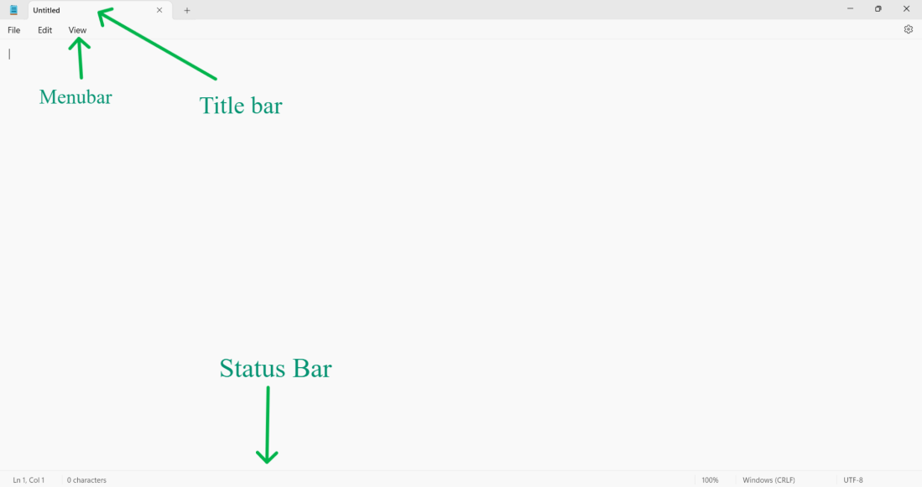 Figure-1: Image showing the menu bar, title bar, and status bar of Microsoft Notepad.

# Chapter-2: Manage Files

## Create a new file in a new tab

You can create a new File in a new tab, which will help you open multiple tabs on the same page, and work on different tabs without closing the File. To create a new file in a new tab, do the following:

1. Click **File**.
2. Click **New tab**. Alternatively, you can click + symbol next to the already appearing tabs. Else, press **Ctrl+N** on the keyboard. A new untitled page appears.

## Create a new file in a new window

You can open a new Notepad page in a new window. To create a new file in a new window, do the following:

1. Click **File**.
2. Click **New window.** Alternatively, press **Ctrl+N** on your keyboard. A new untitled window appears.

## Open an existing File

You can open an existing file and you can update the content. To open an existing file, do the following:

1. Click **File**.
2. Click **Open.** Alternatively, you can press **Ctrl+O** on your keyboard.
3. Select an existing file from a new dialog box.
4. Click **Open.** This opens the existing Notepad**.**

## Save a file

You must save your files often to ensure that the data is saved. To save the files in Notepad, do the following:

1. Click **File**.
2. Click **Save.** Alternatively, you can press **Ctrl+S** on your keyboard.
3. Select the desired location to save the file from the dialog box.
4. Click **Save.**

An image showing the Save and Save As features of Notepad

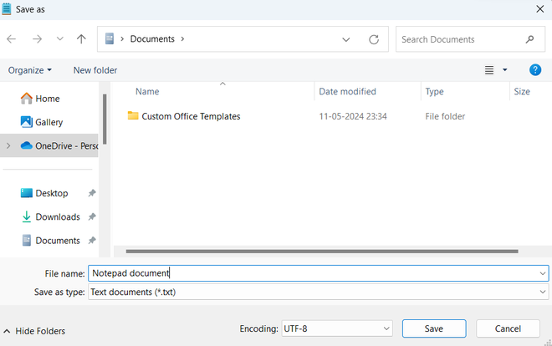Figure-2: An image showing the Save and Save As features of Notepad

## Set Header in Notepad

The header provides the title of the document on top of the page of a printed document. To set the header in Notepad, do the following:

1. Click **File**.
2. Click Page setup.
3. From the **Page setup** dialog box, in the **Header** field**,** enter a desired header note.
4. Click **OK.**

## Set Footer in Notepad

The footer provides the content such as the page number in the bottom right, left, or center of a printed document. To set the footer in Notepad, do the following:

1. Click **File**.
2. Click Page setup.
3. From the **Page setup** dialog box, in the **Footer** field**,** enter a desired footer note. For example: page number 1.
4. Click **OK.**

## Change the Header and Footer commands in Notepad

When you use Notepad in Windows, you can remove or change headers and footers. The default header and footer settings in Notepad are:

* Headers: &f
* Footers: Page &p

These commands give you the title of the document in the upper-right corner of the page and a page number in the lower-right corner of a printed document. The settings cannot be saved, so all header and footer settings must be entered manually each time you want to print a document.

To change headers and footers, do the following:

1. Select **Page setup** from the **File** menu.
2. Enter the desired command(s) in the **Header** and **Footer** text boxes.

Refer to the link for a short list of header and footer commands: [Change Header and Footer Commands in Notepad - Microsoft Support](https://support.microsoft.com/en-us/windows/change-header-and-footer-commands-in-notepad-c1b0e27b-497d-c478-c4c1-0da491cac148)

## Close a file

When you complete the file work, you can close it by saving the content. To close a file in Notepad, do the following:

1. Click **File**.
2. Click **Exit**.

# Chapter-3: Manage Default Settings

You can manage, customize, and edit the page properties such as font, style, and theme.

## Set the page orientation

You can set the page orientation based on your requirements. Managing, customizing, and editing the page orientation such as Portrait, Landscape, and Page Margin levels. To set the page orientation, do the following:

1. Click **File**.
2. Click **Page setup**.
3. In the **Page setup** dialog box, do the following:
4. From the **Size** drop-down menu, select the paper size. For example, if you want to develop content in an A4 size paper, select **A4**.
5. Select the page orientation:

* Portrait—Select to present your content in a portrait mode.
* Landscape—Select to present your content in a landscape mode.
* Margins— Margins refer to the default spacing between the text and the edges of the printed page. Enter a number between 1–10 to indicate the space that must be left on either side of the page. This will be helpful when you print and bind the paper.

**Note:** You cannotcustomize margins within the editor itself; instead, margins are controlled by the printer settings during the printing process.

## Wrap text

You can enable word wrap to ensure that text does not go off the screen horizontally and wraps within the window making it easier to read. To wrap the text in Notepad, do the following:

1. Click **Settings** symbol at the upper-right corner of the page.
2. In the **Text Formatting** section, select the field **Word wrap**.
3. Turn the Radio button to **On**. This enables the **Wrap** feature.

## Enable autocorrect

The feature allows you to autocorrect the text having typographical errors or mistakes. To enable the feature, do the following:

1. Click **Settings** symbol at the upper-right corner of the page.
2. In the **Spelling** section, select the **Autocorrect** field.
3. Turn the Radio button to **On**.

## Enable spell check

The feature helps you to highlight the typographical errors or mistakes in the text. To enable the spell check function, do the following:

1. Click **Settings** symbol at the upper-right corner of the page.
2. In the **Spelling** section, select the **Spell check** field.
3. Turn the Radio button to **On**.
4. Select the drop-down menu in the **Spell check** field and turn the radio button to **On** for all the .dot formats. For example, .txt, .md, lrc, etc.

## Set the page appearance

Starting from Microsoft Notepad 2023, you can set the default properties of your page. You can set the theme based on which a page will appear. To set the page appearance in Notepad, do the following:

1. In the **Appearance** section, from the App theme drop-down menu, select one of the following:

• Light—The page is displayed with a light color theme.

• Dark—The page is displayed with a dark (black) color background.

• Use system settings—Displays the page using the default system settings.

## Set the font properties

You can set the default font style, family, size, and appearance.

1. In the Text **Formatting section**, expand font and to set the Notepad font properties, do the following:

• Family—From the drop-down menu, select the font family. For example, if you want Notepad to use Gothic as the default font, select **Gothic**.

• Style—From the drop-down menu, select a style. The recommended style is **Calibri**.

• Size—From the drop-down menu, select the size. The recommended size is **10**.

# Chapter-4: Print a document in Notepad

You can print a document or a file, which you have created in Notepad. To print a document in Notepad, do the following:

1. Click **File**.
2. Click **Print**. A dialog box appears.
3. In the **Printer** field from the dialog box, from the drop-down menu, select the desired printer.
4. Select the required print settings, such as the number of copies, page orientation, page range, and so on – You also can refer to the sub-topic, **Set the page orientation** inthetopic, **Manage Default Settings**.
5. Click **Print**. Your print starts.

# Chapter-5: Frequently Asked Questions on Notepad – FAQs

Question 1. Can you insert a picture in Notepad?

Answer. No, you cannot add picture in Notepad because it is a plain text editor. To add image, you should prefer Microsoft Word.

Question 2. How to print a Notepad document?

Answer. Steps to print a Notepad document, please refer ‘Manage Default Settings’.

Question 3. Where is Notepad in my Apple Mac?

Answer. Apple Mac does not include Notepad. It has TextEdit program instead.

Question 4. Can you center text in Notepad?

Answer. No, you cannot center text in Notepad because the Notepad is a plain text editor and does not come with in-built features like text formatting or centering text. However, it can be done manually by adding spaces before the text.

Question 5. What are the alternatives of Notepad?

Answer. Sublime Text, Visual Studio Code, UltraEdit, Gedit etc. are the alternative of windows Notepad. These text editors are easily available on internet and simple to use.

# Further topics of Microsoft Notepad are as follows:

Undo, Cut, Copy, Paste, Delete, Find, Find next, Replace, Go to, Select all, Time/Date